**If you see or hear of a fire in another part of the building:**

* **The building is designed to contain a fire in the apartment where it starts. This means it will usually be safe for you to stay in your own home if the fire is elsewhere**
* **You must leave immediately if smoke or heat affects your home or if you are told by the fire service to do so**
* **If there is a lift - do not use it**
* **If you are in any doubt - get out**
* **Call the fire service – dial 999 or 112**

**Wedge fire doors open. Remove wedges if you find them.**

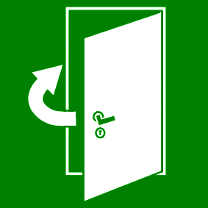

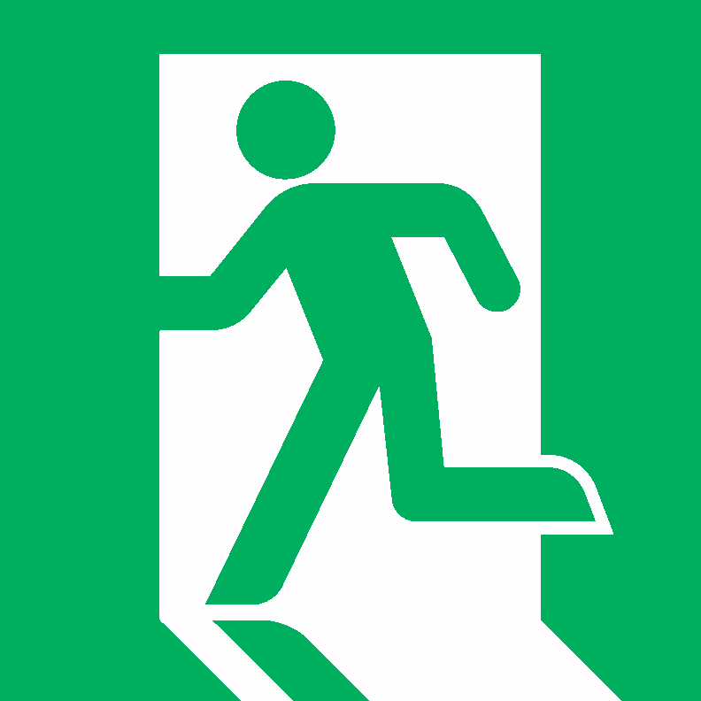**Leave objects on the landing that could be in the way when you try to escape**

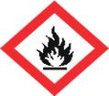**Store gas cylinders, paraffin or other highly flammable liquids in your apartment or store**

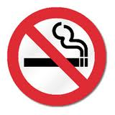**Smoke in communal areas including landings and lifts. It is against the law to do so.**

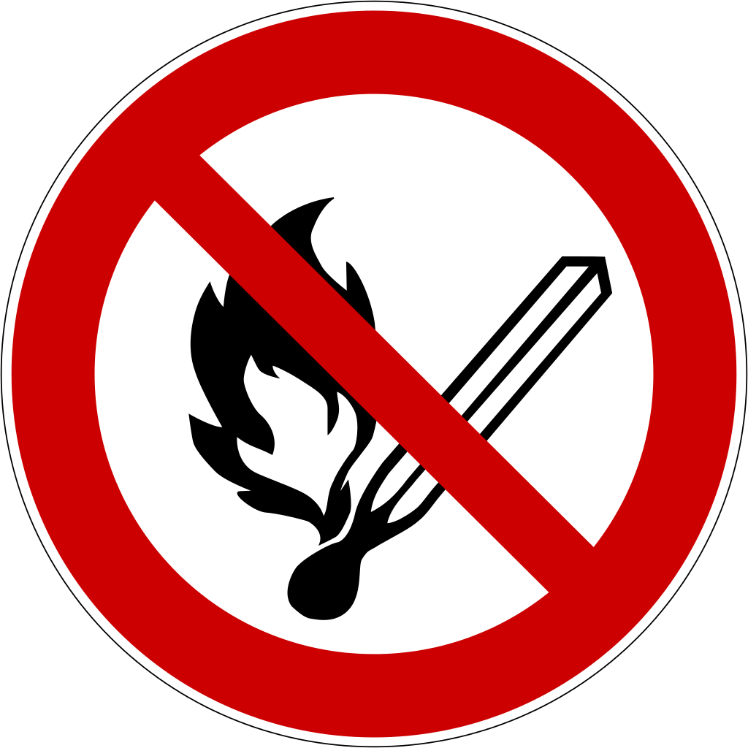**Place candles or tea lights on or near to flammable materials**

**Park or block access to the apartments. Access roads and gates are designed to allow fire appliances to get as close as possible to fight a fire**

**To call the fire service:**

* **Dial 999 or 112**
* **When the operator answers, give your telephone number and ask for FIRE**
* **When the fire service reply give the following address -**
* **Do not end the call until the fire service has repeated the address correctly**

**If the fire breaks out in your home:**

* **Leave the room where the fire is straightaway and close the door**
* **Tell everyone in your home and get them to leave**
* **Close your front door behind you as you leave**
* **Do not stay behind to put the fire out**
* **If there is a lift - do not use it**
* **Wait outside away from the building**
* **Call the fire service – dial 999 or 112**

**DO NOT!**

**Fire Action**