**Remember to check your smoke alarms weekly and report any faults to 01782 968566**

**For more information on fire safety visit our website - www.stokeontrenthousingsociety.org.uk**

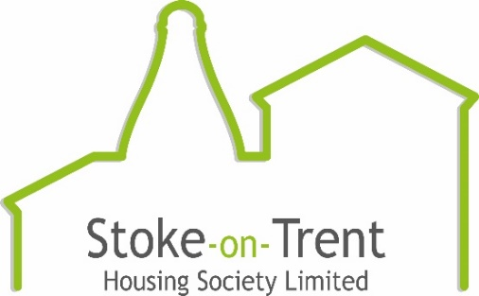

**NEVER**

 **Wedge fire doors open. Remove wedges if you find them.**

**Leave objects on the landing that could be in the way when you try to escape**

**Store gas cylinders, paraffin or other highly flammable liquids in your apartment or shed**

**Smoke in communal areas including landings and lifts. It is against the law to do so.**

**Place candles or tea lights on or near to flammable materials**

**Park or block access to the apartments. Access roads and gates are designed to allow fire appliances to get as close as possible to fight a fire**

**Fire Action**

**To call the fire service:**

* Dial 999 or 112
* When the operator answers, give your telephone number and ask for FIRE
* When the fire service reply give the address where the fire is
* Do not end the call until the fire service has repeated the address correctly

**If you see or hear of a fire in another part of the building:**

* The building is designed to contain a fire in the apartment where it starts. This means it will usually be safe for you to stay in your own home if the fire is elsewhere
* You must leave immediately if smoke or heat affects your home or if you are told by the fire service to do so
* If there is a lift - do not use it
* If you are in any doubt - get out
* Call the fire service – dial 999 or 112

• If there is a lift - do not use it

• If you are in any doubt - get out

• Call the fire service – dial 999 or 112

**If the fire breaks out in your home:**

* Leave the room where the fire is straightaway and close the door
* Tell everyone in your home and get them to leave
* Close your front door behind you as you leave
* Do not stay behind to put the fire out
* If there is a lift - do not use it
* Wait outside away from the building
* Call the fire service – dial 999 or 112